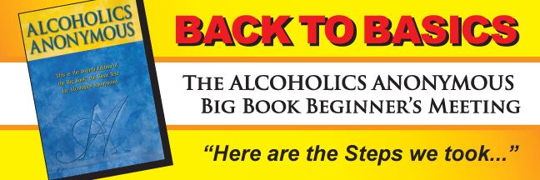

Morning or evening meetings available, the next 4 sessions start:

9:30 AM Thursday September 27Th at A.C.E.

6:45 PM Wednesday September 26Th at A.C.E.

**Alano Club East**

**220 S. Howard Street**

**Lansing MI 48912-4009**

Discover the sheer simplicity of the early AA program that produced a 75% recovery rate from alcoholism. Experience the spiritual awakening that occurs when you take the Twelve Steps in four one-hour sessions.

Based on the number of attendees at Back to Basics A.A. meetings and seminars, more than 500,000 people have now had their lives changed as the direct result of taking the Twelve Steps in four one-hour sessions.  The success of Back to Basics speaks for itself.  "It works--it really does."

Contact: Jim C.: 517-332-3754 or Taylor S.: 517-488-9940