Big Book Experience  We will be taking all 12 Steps following the directions from the book  “Alcoholics Anonymous”. |  |  |  | 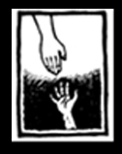
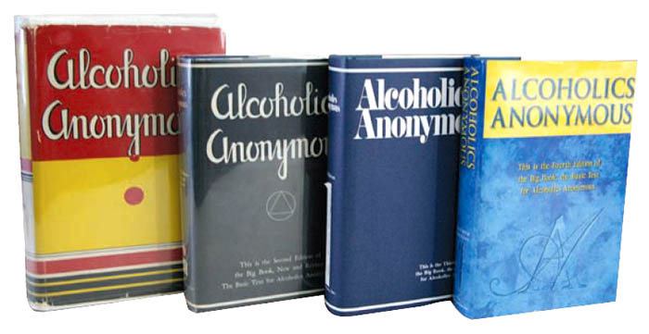 | Sponsored / Hosted by: Spirit way grp.  Location: Saile, AZ  Dine’ college -Student activities rm  (Navajo Reservation)  Date: Saturday October 29th 2011  Time: 9:00am-5:00pm
Presented by: Brian T. – Cottonwood, AZ
928 202-6098 RecoveredAA@Aol.com www.BigBookExperience.org
Schedule  Sat. Morning, 9:00am – 9:45 am  History of the Alcoholics Anonymous  (Break) 9:45am-10:00am  Saturday Morning, 10:00 – 11:15 am  Session # 1 Surrender ~Steps 1, 2, 3  (Break) 11:15am-11:30am  Saturday Afternoon, 11:30am - 12:45 pm  Session # 2 Sharing ~Steps 4 and 5. |  |  | (Lunch Break 1 ½ hr) 12:45pm- 2:00pm  5th Step with Sponsor or Sharing Partner  Saturday Afternoon, 2:00 - 3:15 pm  Session # 3 Restitution ~Steps 6, 7, 8 ,9 +10  (Break) 3:15-3:30pm  Saturday Afternoon, 3:30 - 4:45 pm  Session # 4 Guidance ~Steps 11 + 12
For more info Contact : Davin 928-225-9596
or send e-mail to: DavinKjoe@yahoo.com
---------------------------------------------------------------------------------------------------- Registration form for Attendees
Name(s)_______________ __________________
Address ____________________________________________________
State__________________ Zip____________________
E-mail ______________________@______________________________
willing to volunteer ___yes ____no Help Set-up ____yes

