How to Listen to God ~ Women’s Retreat ~ April 8-10, 2011
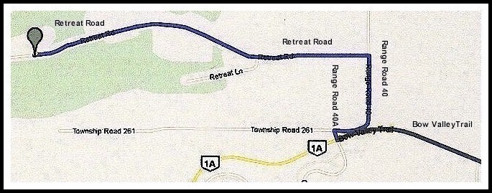
Mount St Francis Retreat Centre

41160 Retreat Road

Cochrane, AB T4C 1A6 CANADA

How to Listen to God Agenda  Friday Evening: 7:00 pm – 9:30 pm  Dinner and Session 1: “God Speaks” and “The Four Standards”  Saturday Morning: 9:00 am - 10:30 am  Session 2: “Surrender” (Steps 1-3) and “Sharing” (Steps 4-7)  Saturday Morning/Afternoon: 11:00 am – 3:30 pm  Lunch and One-on-One Sharing of 4th Step Inventory with Sponsor or Sharing Partner (Step 5) | Saturday Afternoon: 4:00 pm - 5:30 pm  Session 3: “Restitution” (Steps 8-9) and “Guidance” Steps (10-12)  Saturday Evening: 7:00 pm - 9:30 pm  Dinner and Session 4: “The Five C’s of Life-Changing” (Step 12)  Sunday Morning: 9:00 am - 11:30 am  Session 5: “Guidance Meeting” (Practice Step 11) and “Continuance” (Practice Step 12)

Directions to Mount St Francis Retreat Centre  41160 Retreat Road, Cochrane, AB T4C 1A6, CANADA‎  From the Calgary International Airport  2000 Airport Rd NE, Calgary, AB T2E 6W5, CANADA  1. Head west on Airport Rd NE W  2. Turn right at 19 St NE  3. Turn left at Airport Trail NE W  4. After 1.0 km, merge onto Deerfoot Trail/AB-2 N via the ramp to Deerfoot Trail  5. After 5.1 km, take the exit onto Alberta 201 W | 6. After 18.1 km, take the exit toward Rocky Ridge/Royal Oak  7. After 850 m, merge onto Crowchild Trail NW/Alberta 1 Alternate W. Crowchild Trail NW becomes Bow Valley Trail  8. After 15.3 km, turn right at Range Road 40A  9. After 74 m, turn right at Range Road 40  10. After 750 m, take the 1st left onto Retreat Rd  11. After 2.5 km, the Mount St Francis Retreat Centre is on the Right

