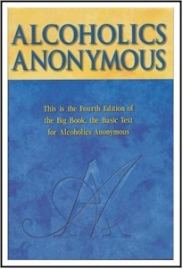
Let’s get ….

BACK TO THE

BASICS

…. of the Big Book

And Do All 12 Steps in One Day!!!

With Mercy Recovery Center-Lisa S. and friends

Sunday, Jan. 6th, 2013 9:00am-4:30pm

Mercy Recovery Center
40 Park Rd. Westbrook, ME 04092
This Seminar is Hosted by Monday night Back to Basics group
This is a seminar for “anyone or everyone interested in a spiritual way of life.” Learn how Dr. Bob and the pioneers used the Big Book to take newcomers through the Twelve Steps with a 50-75% success rate.

Bring your Big Book and bring a friend
A basket will be passed for Pizza

---------------------------------------------------------------------------------------------------

Please Call Lisa S. at 233-6846 to sign up.
Space is limited to 60 people.
The only charge will be for pizza.
We ask for a $5 donation per person for handouts, etc.
You can also bring your own lunch

Back to the Basics of the Big Book

Sunday Morning: 9:00 am - 9:30 am    Overview of the Recovery Process  Sunday Morning: 9:30 am - 9:45 am    Break  Sunday Morning: 9:45 am - 10:45 am    Beginners' Meeting - Session 1~~Steps 1, 2 & 3  Sunday Morning: 10:45 am - 11:00 am    Break  Sunday Morning: 11:00 am - 12:00 noon    Beginners' Meeting - Session 2~~Step 4 | Sunday Afternoon: 12:00 noon - 2:00 pm   Lunch Break (Food Provided by donations)   Fifth Step with Sponsor or Sharing Partner  Sunday Afternoon: 2:00 pm - 3:00 pm   Beginners' Meeting - Session 3 ~Steps 6, 7, 8 & 9  Sunday Afternoon: 3:00 pm - 3:30 pm   Break (Practice Eleventh Step / Write Guidance)  Sunday Afternoon: 3:30 pm - 4:30 pm   Beginners' Meeting - Session 4~~Steps 10, 11 & 12

