Back to Basics ~ Lakewood Community Church
202 E. Lockwood Rd. ~ Coldwater, MI 49036-9001
June 4-5, 2011

Saturday Morning: 9:00 am - 9:30 am   Introductions and Seminar Overview  Saturday Morning: 9:30 am - 9:45 am   Break  Saturday Morning: 9:45 am - 11:00 am   Beginners' Meeting - Session 1~~Steps 1, 2 & 3  Saturday Morning: 11:00 am - 11:15 am   Break  Saturday Morning: 11:15 am - 12:30 pm   Beginners' Meeting - Session 2~~Steps 4 & 5  Saturday Afternoon: 12:30 pm - 2:30 pm   Lunch Break (Food Provided by Host Committee)   5th Step with Sponsor or Sharing Partner  Saturday Afternoon: 2:30 pm - 3:30 pm   Beginners' Meeting - Session 3 ~~Steps 6, 7, 8 & 9  Saturday Afternoon: 3:30 pm - 3:45 pm   Break  Saturday Afternoon: 3:45 pm - 5:00 pm   Beginners' Meeting - Session 4~~Steps 10, 11 & 12 | 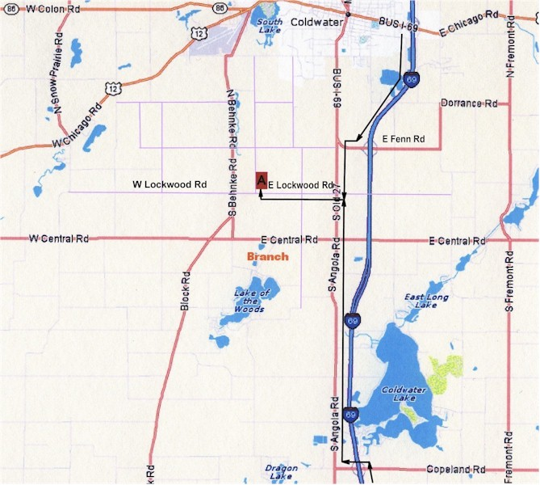

From the West (Chicago Area)  Take I-90 E / I-94 E/DAN RYAN EXPY E toward SKYWAY / INDIANA TOLL RD.  At EXIT 59A, keep LEFT to take I-90 E toward INDIANA TOLL RD (Portions toll) (Crossing into INDIANA).  After 151.3 miles, merge onto I-69 N via EXIT 144 toward LANSING (Crossing into MICHIGAN).  After 4.6 miles, take EXIT 3, the COPELAND RD exit, toward KINDERHOOK.  After 0.4 miles, turn LEFT onto COPELAND RD.  After 0.7 miles, turn RIGHT onto S ANGOLA RD/S OLD 27.  After 6.1 miles, turn LEFT onto E LOCKWOOD RD.  After 1.7 miles, 202 E LOCKWOOD RD is on the LEFT. | From the Northeast (Detroit Area)  Take I-96 W / JEFFRIES FWY toward LANSING.  At the I-96 / I-275 INTERCHANGE, keep LEFT to take M-14 W toward ANN ARBOR.  After 17.4 miles, merge onto M-14 W via EXIT 45 on the LEFT toward ANN ARBOR.  After 4.6 miles, merge onto I-94 W.  After 62.6 miles, merge onto I-69 S via EXIT 108 toward FT WAYNE.  After 29.1 miles, take EXIT 10 toward FENN RD.  After 0.4 miles, turn RIGHT onto I-69-BUSINESS LOOP.  After 0.6 miles, turn LEFT onto ANGOLA RD.  After 1.2 miles, turn RIGHT onto E LOCKWOOD RD.  After 1.7 miles, 202 E LOCKWOOD RD is on the LEFT.
From the South (Ft Wayne Area)  Take I-69 N toward LANSING MI. (Crossing into MICHIGAN).  After 48.0 miles, take EXIT 3, the COPELAND RD exit, toward KINDERHOOK.  After 0.4 miles, turn LEFT onto COPELAND RD.  After 0.7 miles, turn RIGHT onto S ANGOLA RD/S OLD 27.  After 6.1 miles, turn LEFT onto E LOCKWOOD RD.  After 1.7 miles, 202 E LOCKWOOD RD is on the LEFT | From the East (Toledo Area)  Take I-75 S toward DAYTON.  Take EXIT 195, the OH-795 / I-80 / I-90 / OHIO TURNPIKE exit, toward PERRYSBURG.  After 0.3 miles, take the I-80 / I-90 / OHIO TURNPIKE exit, EXIT 195B, toward TOLL ROAD.  After 0.8 miles, merge onto I-80 W / I-90 W toward CHICAGO (Portions toll) (Crossing into INDIANA).  After 77.4 miles, merge onto I-69 N via EXIT 144 toward LANSING (Crossing into MICHIGAN).  After 4.9 miles, take EXIT 3, the COPELAND RD exit, toward KINDERHOOK.  After 0.4 miles, turn LEFT onto COPELAND RD.  After 0.7 miles, turn RIGHT onto S ANGOLA RD / S OLD 27.  After 6.1 miles, turn LEFT onto E LOCKWOOD RD.  After 1.7 miles, 202 E LOCKWOOD RD is on the LEFT.

