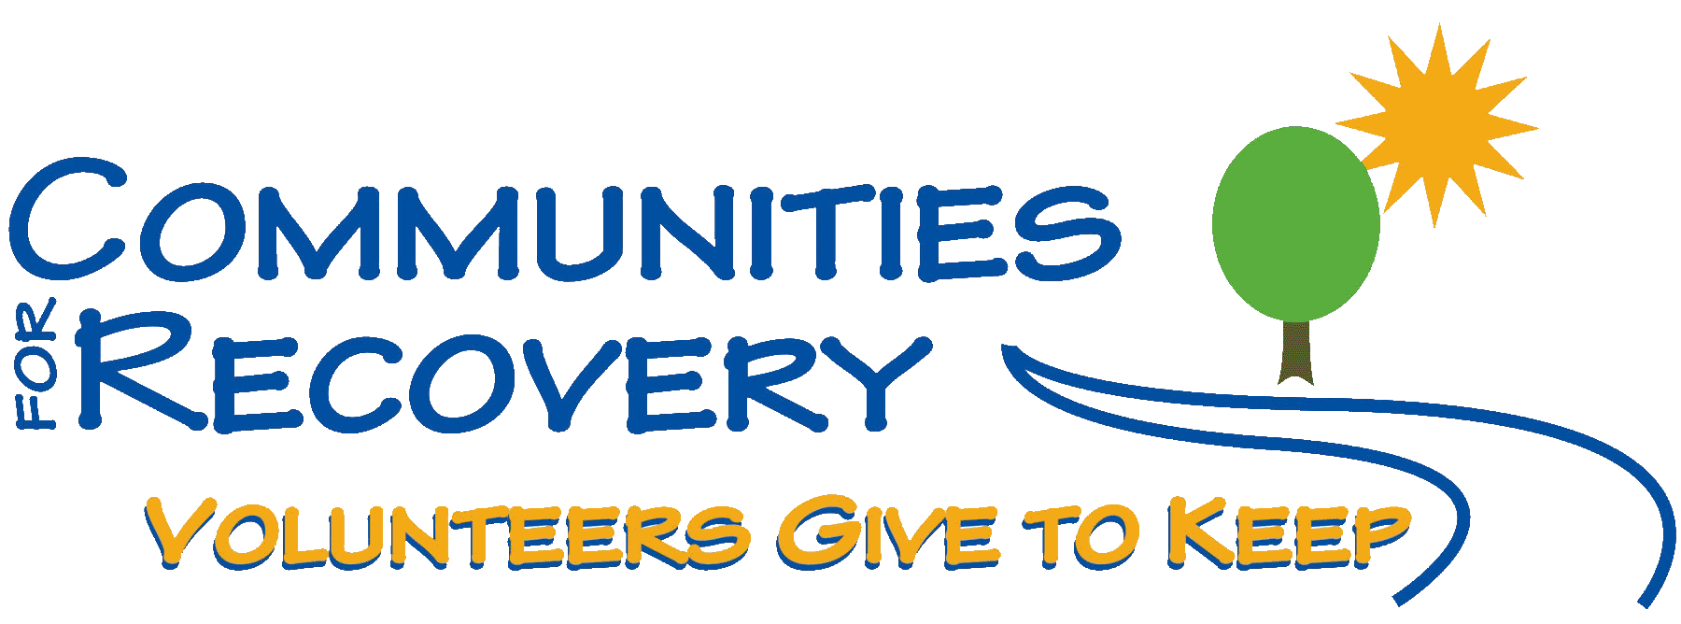

PRESENTS

Back to The Basics of Recovery
with Wally P. (Tucson, AZ) Archivist and Historian

Wally P. has spent more than 20 years researching, interviewing, documenting, presenting, and writing about the history of the Twelve-step movement.” He has announced he will not be traveling in 2012. This may be your last chance to gain insight from Wally personally about our “early days.”
“This is an experience you must not miss. We know you will not want to miss it.”

Bring your Sponsor and Sponsees and
TAKE all Twelve Steps

Saturday, July 23, 2011
9:00 a.m. – 4:30 p.m.

Austin State Hospital – All Faith’s Chapel
4110 Guadalupe St. – Austin, Texas 78751-4223

Sunday, July 24, 2011
10:00 – 11:00 a.m.
Eleventh Step Guidance Meeting

Austin State Hospital – All Faith’s Chapel
4110 Guadalupe St. – Austin, Texas 78751-4223

Suggested Donation: $35.00
(Scholarships are available for those who cannot afford the suggested donation)

Includes: Cost of Seminar, Saturday Lunch, 20+ hand-outs, and Guidance Journal

For more information, call 512-785-7686
or visit, www.cforr.org

