Back to the Basics of Recovery
Austin State Hospital ~ 4110 Guadalupe St.
Austin, TX 78751-4223

Saturday Morning: 9:00 am - 9:30 am   Introductions and Seminar Overview  Saturday Morning: 9:30 am - 9:45 am   Break  Saturday Morning: 9:45 am - 10:45 am   Beginners' Meeting - Session 1~~Steps 1, 2 & 3  Saturday Morning: 10:45 am - 11:00 am   Break  Saturday Morning: 11:00 am - 12:15 pm   Beginners' Meeting - Session 2~~Steps 4 & 5  Saturday Afternoon: 12:15 pm - 2:15 pm   Lunch Break (Food Provided by Host Committee)   5th Step with Sponsor or Sharing Partner  Saturday Afternoon: 2:15 pm - 3:15 pm   Beginners' Meeting - Session 3 ~~Steps 6, 7, 8 & 9  Saturday Afternoon: 3:15 pm - 3:30 pm   Break  Saturday Afternoon: 3:30 pm - 4:30 pm   Beginners' Meeting - Session 4~~Steps 10, 11 & 12 | 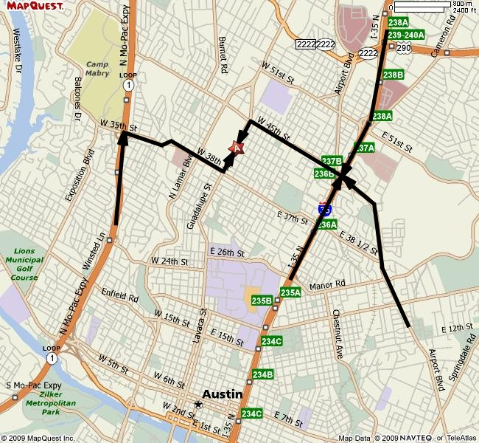

From the West  Take I-10 EAST  Merge onto US-290 E via EXIT 477 toward FREDRICKSBURG.  After 71.8 mi, turn SLIGHT RIGHT onto US-281 S/US-290 E.  After 5.6 mi, turn SLIGHT LEFT onto US-290 E.  After 33.3 mi, US-290 E becomes US-290 E.  After 0.2 mi, merge onto US-290 E/TX-71 E via the ramp on the LEFT.  After 1.5 mi, take the TX-1-LOOP N exit.  After 0.7 mi, merge onto TX-1 LOOP N/S MO-PAC EXPY.  After 6.4 mi, take the 35TH ST exit.  After 0.1 mi, turn SLIGHT RIGHT onto W 35TH ST.  After 0.4 mi, stay STRAIGHT to go onto W 35TH ST CUTOFF  After 0.1 mi, W 35TH ST CUTOFF becomes W 38TH ST.  After 0.7 mi, turn LEFT onto GUADALUPE ST.  After 0.3 mi, end at 4110 Guadalupe St Austin, TX 78751 | From the Northeast (Dallas area)  Take I-35 SOUTH toward AUSTIN  Take EXIT 237A toward AIRPORT BLVD/ 38 1/ 2 ST.  After 0.1 mi, stay STRAIGHT to go onto I-35 N.  After <0.0 mi, take the ramp toward I-35 N/ AIRPORT BLVD.  After 0.1 mi, keep RIGHT at the fork to go on AIRPORT BLVD.  After 0.1 mi, turn LEFT onto E 45TH ST.  After 1.1 mi, turn LEFT onto GUADALUPE ST.  After 0.3 mi, end at 4110 Guadalupe St Austin, TX 78751
From the Southwest (San Antonio area)  Take I-35 NORTH toward AUSTIN.  After passing downtown AUSTIN, keep RIGHT to take I-35 N/ US-290 E/US-81 N toward AIRPORT BLVD/51ST-CAMERON RD.  After 1.7 mi, take EXIT 237A toward AIRPORT BLVD.  After 0.1 mi, take the AIRPORT BLVD NORTH ramp.  After 0.1 mi, turn LEFT onto AIRPORT BLVD/TX-111 LOOP.  Continue to follow AIRPORT BLVD.  After 0.2 mi, turn LEFT onto E 45TH ST.  After 1.1 mi, turn LEFT onto GUADALUPE ST.  After 0.3 mi, end at 4110 Guadalupe St Austin, TX 78751 | From the East (Houston area)  Take I-10 WEST.  Merge onto TX-71 W via EXIT 695 toward LA GRANGE/ AUSTIN.  After 81.9 mi, merge onto US-183 N.  After 1.9 mi, take the AIRPORT BLVD/TX-111-LOOP ramp  Toward TX-343-LOOP/1ST-5TH-7TH STS.  After 0.2 mi, keep RIGHT at the fork in the ramp.  After 0.2 mi, stay STRAIGHT to go onto AIRPORT BLVD/TX-111  LOOP N.  Continue to follow AIRPORT BLVD.  After 3.9 mi, turn LEFT onto E 45TH ST.  After 1.1 mi, turn LEFT onto GUADALUPE ST.  After 0.3 mi, end at 4110 Guadalupe St Austin, TX 78751

